**FOR AND WHILE**

1. What is for loop?
   1. For loop គឺជាការ loop​ ទៅតាមចំនួនកំណត់ ។
2. What is while loop?
   1. While loop គឺជាការ loop នៅពេលលក្ខណមិនពិតទើបវាឈប់ដើរ ។
3. I want to display number from 0 to 9 using for loop

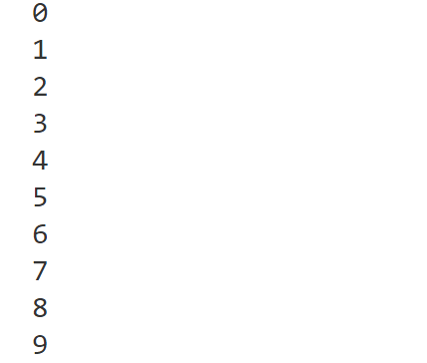

for i in range(10):

    print(i)

1. I want to display number from 0 to 9 using while loop



number =0

while number <=9:

    print(number)

    number +=1

1. I want to display **odd number** from 0 to 9 using for loop

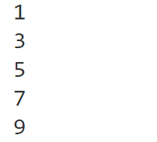

for i in range(10):

    if i %2 ==1:

        print(i)

1. I want to display **odd number** from 0 to 9 using while



number =0

while number <=10:

    if number %2 ==1:

        print(number)

    number +=1

1. I want to display **even number** from 0 to 9 using for loop

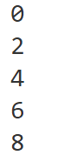

for i in range(9):

    if i % 2 ==0:

        print(i)

1. I want to display **even number** from 0 to 9 using while



number =0

while number <=9:

    if number % 2 ==0:

        print(number)

    number +=1

1. I want to display **number are smaller than 5** from 0 to 9 using for loop

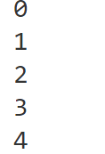

for i in range(9):

    if i <5:

        print(i)

1. I want to display **number are smaller than 5** from 0 to 9 using while



number =0

while number<9:

    if number<5:

        print(number)

    number +=1

1. I want to display **number are greater than 5** from 0 to 9 using for loop

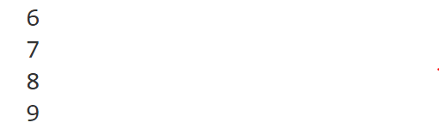

for i in range(9):

    if i <5:

        print(i)

1. I want to display **number are greater than 5** from 0 to 9 using while



number =0

while number<10:

    if number >5:

        print (number)

    number +=1

1. I want to sum of numbers from user input using for loop

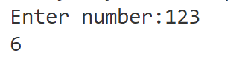

number ="123"

n=0

for i in range(len(number)):

    n  += int(number[i])

print(n)

1. I want to sum of numbers from user input using while loop



number ="123"

i = 0

sum = 0

while i < len(number):

    sum +=int(number[i])

    i += 1

print(sum)